<https://github.com/boboppie/coursera-course-statistics_one>

**LECTURE 8– Multiple Regression**

**Segment 1: Intro to Multiple Regression**

^Y = B0 + B1X1 + B2X2 + B3X3 +….+ BkXk -🡪 ^Y =B0+E(Bk+Xk)

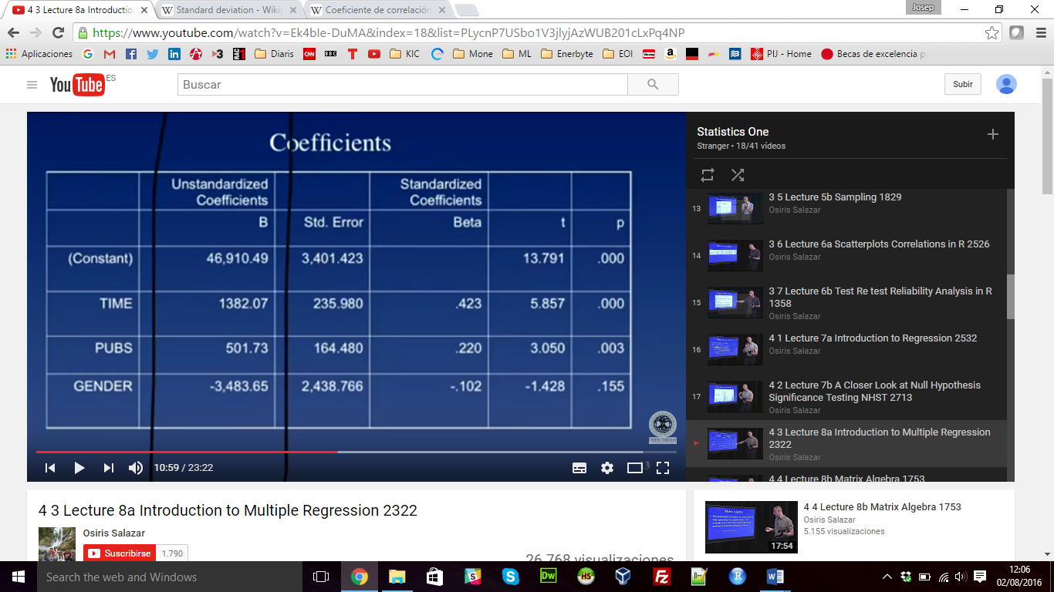

Model R and R2:

* R is multiple correlation coefficient R = rÝY
  + Correlation between predicted scores and observed scores
* R2 is the percentage of variance in Y explained by the model

Standard multiple regression:

* All predictors into equation at the same time

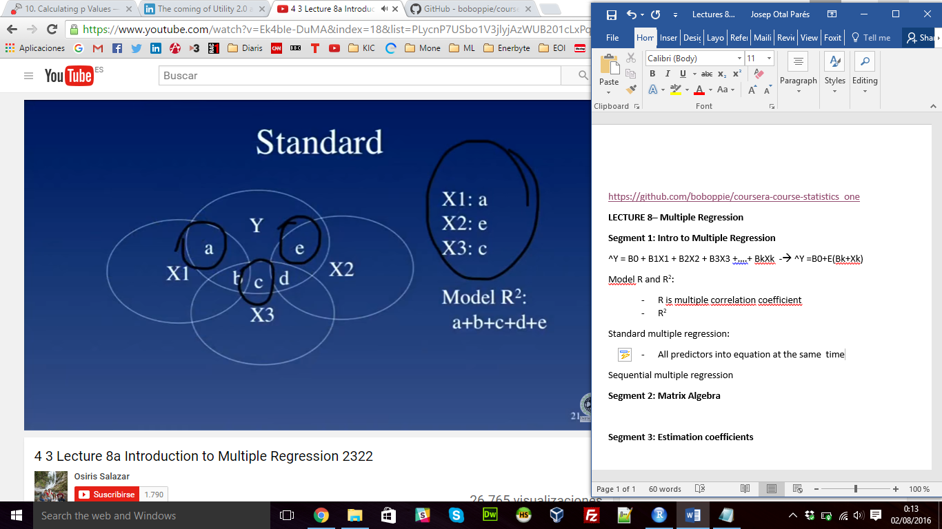

Sequential multiple regression

* Predictors are entered in steps

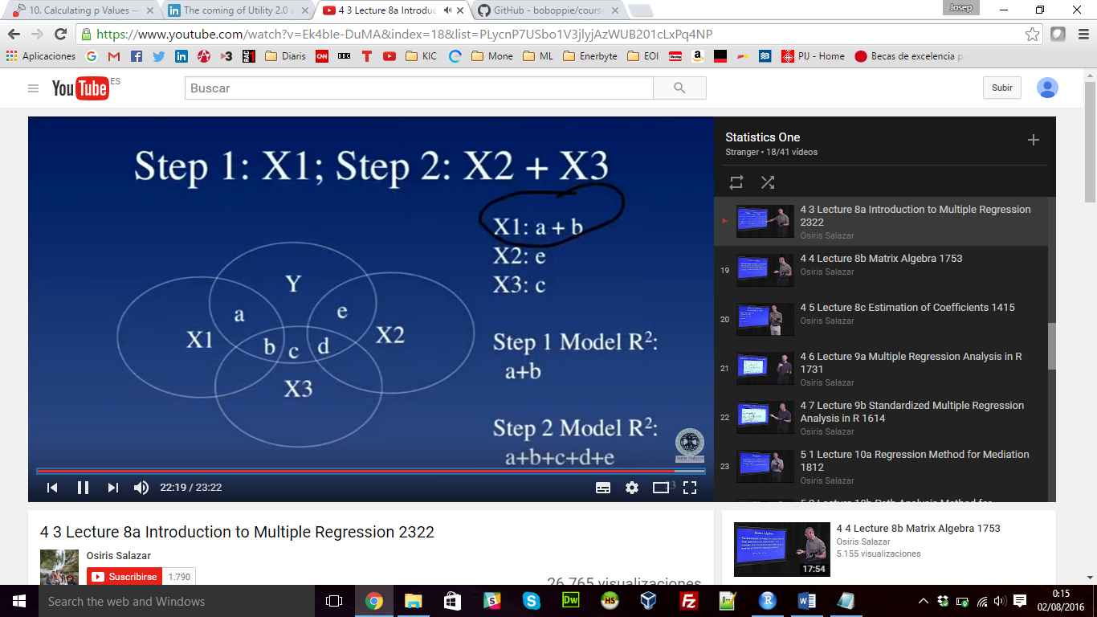

**Segment 2: Matrix Algebra**

* Matrix M
* Transpose matrix MT
* Diagonal matrix
* Inverse matrix D-1: reciprocal (only for square matrices)
* Identity matrix I = D* D-1
* Determinatnt |A|= a11*a22-a12*a21
* Vector
* See “Lecture8.2-matrix algebra.R”

**Segment 3: Estimation coefficients**

^Y = B0 + B1*X1

Y-^Y = e

* ^Y = BX
  + ^Y is [Nx1] column vector
  + B is a [k x1] vector
  + X is a [Nxk] matrix
* Replace ^Y with Y 🡪
  + **Y = XB**
  + **X’Y = X’ XB** (multiply both side by X’, transposed X)
  + (X’X)-1X’Y = (X’X)-1X’XB (multiply both sides by the identity matrix)
  + (X’X)-1X’Y = IB 🡪 (X’X)-1X’Y = B
  + B = (X’X)-1X’Y 🡪 B = (Sxx)-1 *Sxy

Multiple R-squared: 0.1133 🡪 explains the 11,3% of the variance